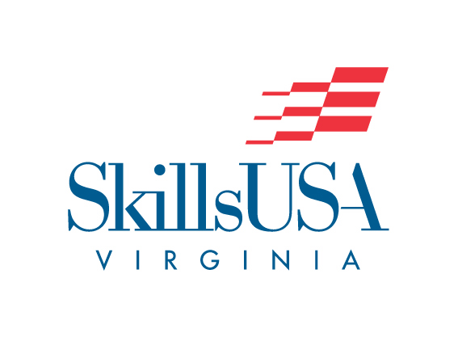
In this letter
- SLC Dates and Survey
- Membership
- PIN/T-shirt Design CONTEST CHANGES/due date
- State Officer Workshop
- Pre-submitted contests/website
- Payment Address
- CTE CareerSuccess Stars
- National Signing Day
- State Director Contact

  - January 7, 2025
  - Happy New Year!!
State Leadership Conference
Dates confirmed
April 4, 5 & 6
Berglund Center
Roanoke, VA
Hotel Info to be posted SOON!

https://forms.gle/6UGGtFAWdPh9tf2g7
If you have not taken survey, please take a few minutes to complete the questions about future SLC’s.

MEMBERSHIP
Membership Registration is open until
March 1! You must be a submitted member to participate in any event!
Students - $15
Professional - $29

Changes to PIN Competition –
Pin Competition #1-
This competition is the state pin design. It will move to the National competition and compete against other State pins. Technical Standards can be found in ABSORB. The student designs a pin for the state. This is NOT the pin that is used for the trading pin at the National conference. The standards for this competition can be found in the technical standards and will be judged at the State conference. It will advance to Nationals. It is NOT pre submitted. This design is submitted at SLC.

Pin competition #2 –
There is a National pin Design Competition-
Students may submit a design to the National Office to be considered as the NATIONAL DESIGN for the year. Information on this will be posted to the National site at www.skillsusa.org
Everyone whoo attends National Conference is given a National pin.

Pin competition #3 –
This is the NEWLY updated Virginia competition. Our trading pin design will no longer be submitted to the National pin design – but we are looking to enlarge and be more creative with our trading pin.
Please see the new attached standards. We want our students to be creative and not have to follow the National guidelines for our trading pin.
DESIGNS DUE March 3, 2025

Pin Design #4 –
ADVISOR DESIGN –
This pin will be a trading pin – sold as a limited edition at the National Conference. It will be designed by one of our Advisors.
Please see the Attached Standards.
DESIGNS DUE March 3, 2025

Please contact Joyce Price at director@skillsusava.org with any questions!!

T-shirt Designs due March 3, 2025

T-shirt and Trading Pin Designs should be mailed to:
SkillsUSA VA
Virginia Cooperative Extension State Office
Attn:Joyce Price
115 HutchesonHall
250 Drillfield Drive
Blacksburg, VA 24061

Pre-Submitted Contests:
All pre-submitted contests must be postmarked by March 3.
Please check the website for updates on mailing or digital information as per contest.

We ask for your patience as the website is being updated.

Do you have students that want to be State Officers?
Do you have questions about the process?
Sign up NOW!! Limited space.
State Officer Information Training
February 5, 10 am – 1:30 pm
Lunch provided
$15.00
T.C. Walker Educational Center
6099 T.C. Walker Road
Gloucester, VA 23061
(See attached flyer)

(Possible Southwest location)

Reminder:
SkillsUSA Virginia is at
Virginia Tech!

All payments other than membership should be mailed to:
Virginia Cooperative Extension – State Office
Attn: SkillsUSA Virginia
115 Hutcheson Hall
250 Drillfield Drive
Blacksburg, Virginia 24061

CTE CAREER SUCCESS STARS

The Office of Career, Technical, and Adult Education is seeking nominations of former CTE students who qualify for recognition as one of the Commonwealth’s brightest Career Success Stars. The individual success stories will be featured as video profiles on the VDOE’s website, highlighting how CTE programs provide academic and technical skills for postsecondary success.
Nominees should be former CTE students in their 20s and 30s who represent each of the 17 career clusters as well as a U.S. military branch. Once selections are made, individuals will be contacted to schedule an appointment for a photograph and video recording session. Parents of the Career Success Stars nominees may also be interviewed and featured on the VDOE website.
Please complete the CTE Career Success Stars Nomination form for each former student you wish to nominate

SkillsUSA National Signing Day
The SkillsUSA National Signing Day is May 6, 2025 Register on the national site!
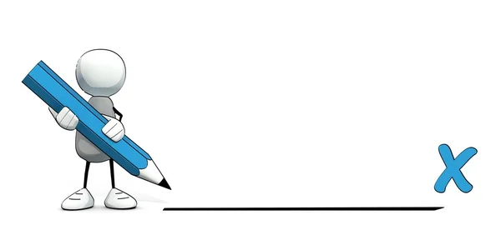
Tap here to add a caption
Contact Us
Company Name
Street Address
City, ST ZIP Code
Telephone
Email
Website
SkillsuSA Virginia
Virginia Cooperative Extension – State office
115 Hutcheson hall
250 Drillfield Drive
blacksburg, virgnia 24061
director@skillsusava.org
540-750-6896
www.skillsusava.org

Need help?
If you need help registering, membership, or if you have general questions please contact you State Director, Joyce Price, director@skillsusava.org or call at 540-750-6996

If you have used the email stateadvisor@skillsusava.org and I have not replied, please contact me again at director@skillsusava.org. I have not received all messages at the State Advisor address.

