Hello and welcome from SkillsUSA and congratulations on making it to this level of the Automotive contest.
Here are some of the details you will need to know about the contest.
It will be held at :
Roanoke Technical Education Center
2200 Grandin Road
Roanoke, VA 24015

The contest will be located close to the baseball field.

Richard Durrett ROTEC instructor and primary contact at the contest location.
Cell phone :540-353-4726

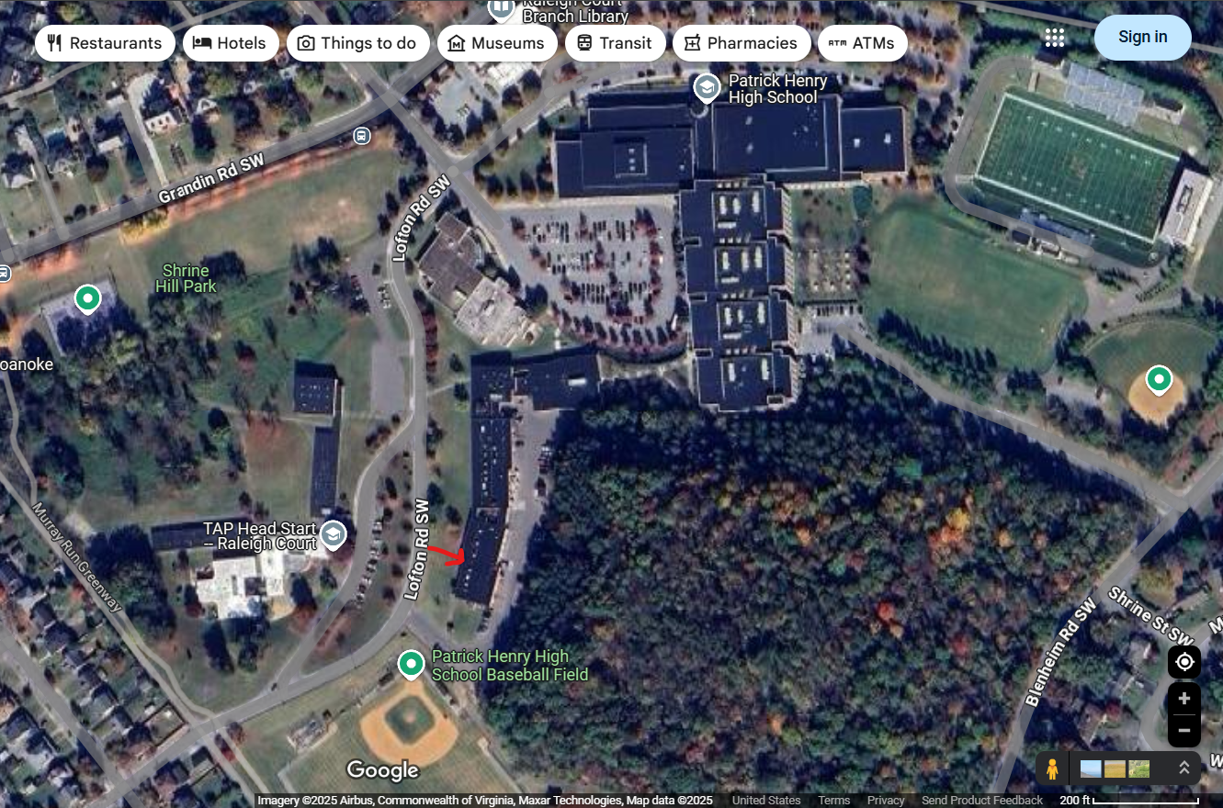

You will need to check in at the Berglund center on Friday to register and receive your contest information pack.
On Saturday you will need to be ready to ride the bus from Berglund at 7:15am.
When you show up to the contest location you will need the following:
A redacted resume’ (nothing on the resume’ to identify the student).
The correct uniform shirt required by SkillsUSA.(make sure you are not wearing anything to identify where you are from).
Safety glasses
No open-toed shoes.
A great attitude.
We will be having contest that will incorporate a scanner and a DMM. You can bring your own if you choose.

