Links and info for Skills competition 2025

Signing up on Axalta Academy

Access to On Line training modules containing safety, mixing, application, and cleanup of all products Axalta has available.

How – go to <https://www.axalta.com/us/en_US/products-and-customers/training.html>

Scoll down and click . Then go to Register New user. After profile is created, it may take 24 hours for your account to be active. You will have access to all Axalta Brands. You will click on the words Spies Hecker.

Then click on the Learning Content, Online, and sort Spies Hecker.

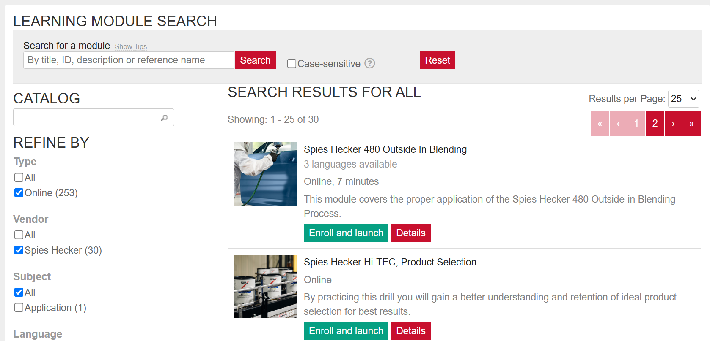

Then click on which product that the person wants to be trained on. I suggest starting with the videos that reflect what products will be used during Skills Competition.

