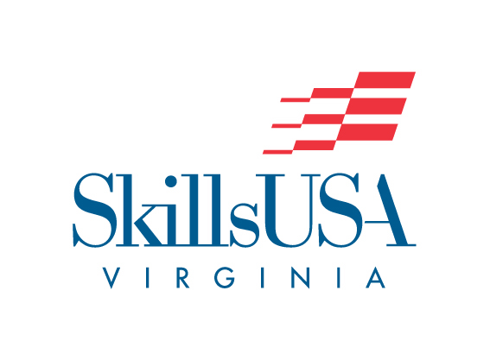

**CURRENT EVENTS**

**Purpose**

To evaluate each contestant’s awareness of events happening in today's society

**Clothing Requirement**

SkillsUSA official attire or clothing that is appropriate for an interview should be worn.

**Eligibility**

This contest is open to active SkillsUSA members.

**Observer Rule**

No observers will be permitted to view the contest in progress.

**Equipment and Materials**

1. Supplied by the technical committee:

Test

Chairman and judges

No. 2 pencils

Tables and chairs

2. Supplied by the contestant:

One-page, typewritten résumé

**Scope of the Contest**

1. Questions for the State Current Events Contest will be selected from the past three months of the current year of Information available on National news.

2. The Current Events Contest shall be composed of multiple choice, true/false, or matching questions.

3. Each contestant shall be given the same set of questions to be answered.

4.. One test containing 25 test items will be administered.

5. Thirty minutes will be allowed to complete the 25-question test.

6. Only one answer will be accepted for each question. The contestant shall suffer the penalty of a wrong answer upon violation of this rule.

7. Contestants must remain seated and quiet during the full 45 minutes.

8. Contestants will remain in the testing area until dismissed by the contest proctor

**Contest Submission**

Submit the following:

* One-page typed resume for each team member. Resume rubric available at [www.skillsusava.org](http://www.skillsusava.org)