Marine Service Technology

Sponsored by Yamaha

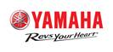

Please follow the National Technical Standards.
Everything will be provided for your contest.

