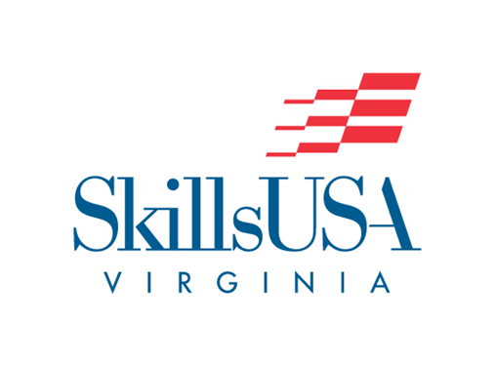

Poster

Purpose
To evaluate the contestant’s ability to develop and prepare a SkillsUSA Virginia promotional poster

Clothing Requirement
This contest does not require an interview; However, contestants should be dressed in SkillsUSA attire or business dress when submitting poster design and for the awards ceremony.

Eligibility
This contest is open to active SkillsUSA members

DEADLINE
The contestant shall submit the poster, verification in the appointed content area on the day of the Leadership and Skill Competitions.

Exhibit of Entries
Entries will be exhibited and judged on the SkillsUSA competition floor. Posters will be displayed for viewing.

Pickup of Entries
SkillsUSA Virginia will not be responsible for posters that have not been removed from the exhibit area by 2 p.m. on the day of the skill competitions. Failure to remove posters by this deadline could result in their damage or destruction by the cleaning crew.

Equipment and Materials
1. Supplied by the technical committee:
a. Six-foot tables
b. No. 2 pencils
c. Three-to-five judges
d. One tape measure
2. Supplied by the contestant:
a. Finished poster
b. One-page, typed résumé
c. Verification form

Scope of the Contest
1. Posters will be original artwork only. They may not be computer generated.
2. The theme for the poster will be the current National SkillsUSA theme and it must be stated on the poster. To verify the national theme, go to http://www.skillsusa.org/about/theme/ .
3. The poster shall be designed and constructed by SkillsUSA Virginia members only.
4. Entries should be constructed on white 22"x 28" poster board. The size of the board is measured from the base of the poster board. Penalty: Five points will be deducted for each 1/8" over the prescribed size.
5. Entries may not have any attachments to the poster (e.g., molding, framing, mock-ups, modules, photographs, collages, and stick-ons).
6. Posters must be submitted at the designated location on the day of competition.
7. A Verification Form stating that the poster was the original, creative work of the individual chapter member, must be submitted. The form is to be signed by the student, SkillsUSA advisor, and school administrator and placed in a plain envelope on the back of the poster.
8. The poster should possess educational information value, meaning the design relates to education.

