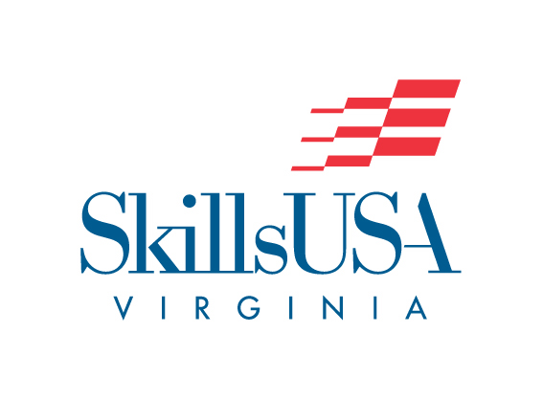

**Spelling**

**Purpose**

To evaluate each contestant’s spelling abilities

**Clothing Requirement**

SkillsUSA Official dress or Professional dress.

**Eligibility**

This contest is open to all active SkillsUSA members

**Exhibit of Entries**

No Observers will be allowed to view the contest in progress

**Equipment and Materials**

Supplied by Technical committee:

* Tables and chairs
* Paper and pencils
* Chair and judges
* Words for test

Supplied by contestant:

* One-page typewritten resume

**Scope of Contest**

1. You will be given an oral spelling test
2. Words will be repeated by the judge three times
3. All words will be taken from the SkillsUSA Handbook
4. Please do not leave the area after the test in case a second round is required
5. You will prepare and submit a one-page typewritten resume. Sample outline can e found on the SkillsUSA VA website. [www.skillsusava.org](http://www.skillsusava.org)